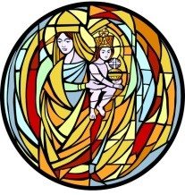 Our Lady of Prompt Succor

Parish School of Religion

For children who do not attend Catholic school

**2025 – 2026 K – 10th Grade Calendar**

**Contact Shanon Alfonso at** [**salfonso@olps-chalmette.org**](mailto:salfonso@olps-chalmette.org)

**Daytime phone 504-271-3441 ext 0 - Evening phone (during class only) 504-512-5960**

**All K-10th Grades Classes are on Monday night from 6:30 pm to 8:00 pm**

**All students are to be dropped off in the gym by 6:30pm but no earlier than 6:15pm.**

**All students will be dismissed from the gym carline at 8:00pm**

**PSR students attend mass together once per month. All students are to be dropped off in the gym and will be walked to church by their teachers. Mass begins promptly at 6:45pm. Parents/families are invited.**

**August**

**3 Blessing of the Backpacks Sunday, 10:30am Mass – All invited to bring their backpacks to be blessed.**

**18 Opening PSR Mass and Parent meeting – (All meet in the Church)**

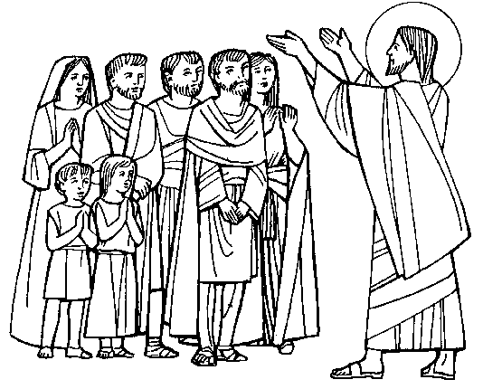**24 Sunday, 10:30am 8th – 12th Grade Family Mass**

**25 Class**

**September**

**1 NO CLASS Labor Day**

**8 PSR Mass**

**15 Class**

**21 Catechetical Sunday 10:30am Mass – All catechists attend**

**22 Class**

**28 Sunday, 10:30am 7th Grade Family Mass (Family Day - refreshments and social following)**

**29 Class**

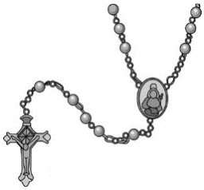

**October**

**6 PSR Mass Followed by Living Rosary**

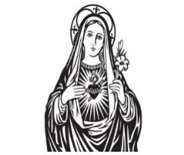**13 No Class – Fall Break**

**19 10:30am 6th Grade Family Mass**

**20 Class**

**27 Class**

**November**

**3** **PSR Mass**

**10 Class – First Reconciliation Parent Session**

**16 10:30am Sunday Family Mass - 5th Grade**

**17 Class**

**24 NO CLASS - Happy Thanksgiving Holidays**

**December**

**1 Class – Reconciliation for grades 3 – 10**

**6 Santa Breakfast and Santa’s Secret Workshop (Purchase tickets in advance or at the door)**

**8 PSR Mass in Gym– Christmas carols following**

**14 10:30am Sunday Family Mass - 4th Grade**

**15 NO CLASS – Have a Blessed Christmas and Happy New Year**

**22** **NO CLASS – Have a Blessed Christmas and Happy New Year**

**29 NO CLASS – Have a Blessed Christmas and Happy New Year**

**January**

**5 PSR Mass**

**11 First Reconciliation Family Prep Day 9:00am-11:30am – (Student and parents attend.)**

**11 10:30am Sunday Family Mass - 3rd Grade**

**12 Class**

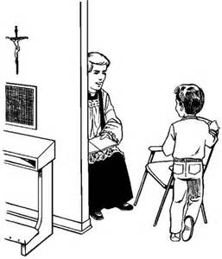**19 NO CLASS – MLK Holiday**

**21 Wednesday, First Reconciliation - 6:00pm in church**

**26 Class**

**February**

**1 10:30am Sunday Family Mass – 2nd Grade**

**2 PSR Mass Day**

**9 Class - Meeting 1st Communion parents in cafeteria 6:30pm**

**16 No Class – Mardi Gras Break**

**23 Class**



**March**

**2 PSR Mass Day**

**9 Class**

**16 Class**

**22 1st Grade Family Mass 10:30am Sunday**

**23 Class - Reconciliation in Church – Grades 3rd through 10th**

**30 Class**

**April**

**6 No Class – Easter Break**

**12 PreK – K Family Mass**

**13 LAST PSR CLASS – (All meet in Church) Closing Mass**

**17-19 !Tomato Fest!**

**26 Saturday, First Communion Family Prep Day 9:00am – 11:30am (Students attend with parent)**

**27 PSR First Eucharist Rehearsal and Family prayer service (All Students + 1parent) 6:30pm in Church**

**MAY**

**3 1st Communion and May Crowning 8:30am Mass or 1:00pm Mass (Spanish)**